Assignment No | 1
Title | Implementing partioning concept
Objective | Learn Range and list partioning
Roll No | MCA2565

1.Created a table with range partition
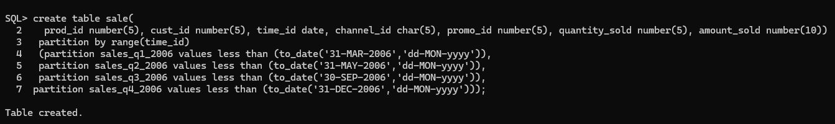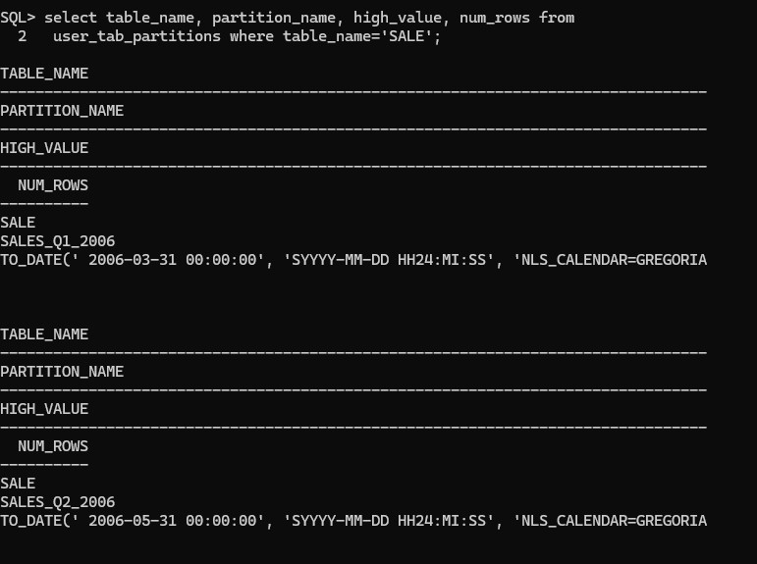
2
.partition

3.insert a data into partition
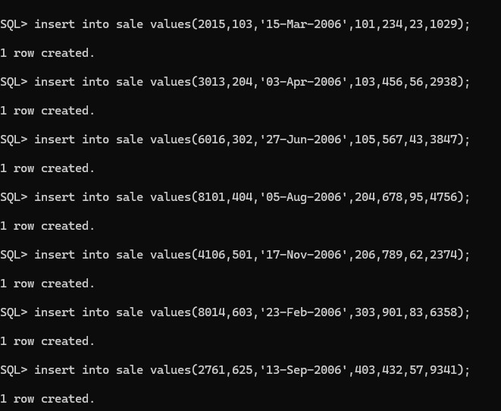
4. Partition with data
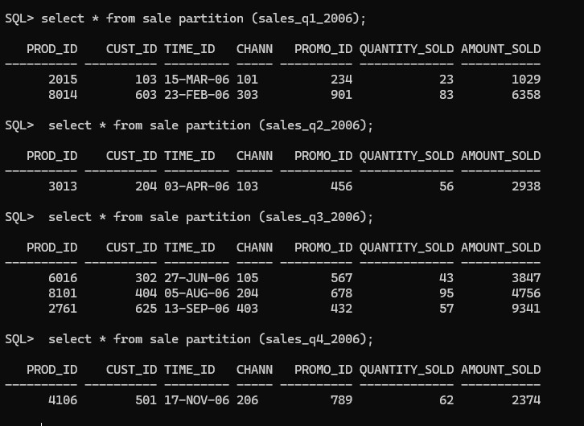
5
.adding new partition

6.showing new partition
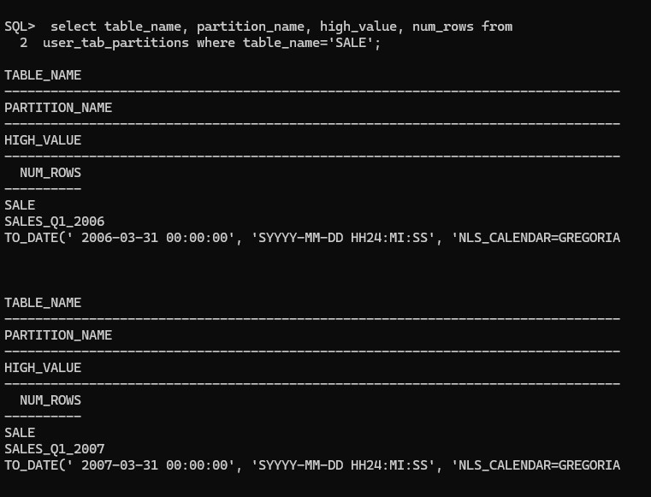
- Delete a data from table by truncate command

alter table sale truncate partition sales_q2_2006

- Deleting partition by drop command
